**Frievent System Architecture**

**Use Cases**

1. **Register:** User fills required information and clicks the register button. App sends a request to create a new user to our database and if the response is true the user gets a success message.
2. **Login**: User fills required information and clicks the login button. App sent a request to check username and password from database and if it is correct send a token response and navigate to main page
3. **Check Activity**: App sends a get request to database and shows response in a page.
4. **Join Activity**: User clicks to an event and sends a request to join to the event.
5. **Create Activity**: User fills required parts of form and sends a request to create new activity in the database. If everything is valid, the user gets a success message.

**Use Case Diagram**

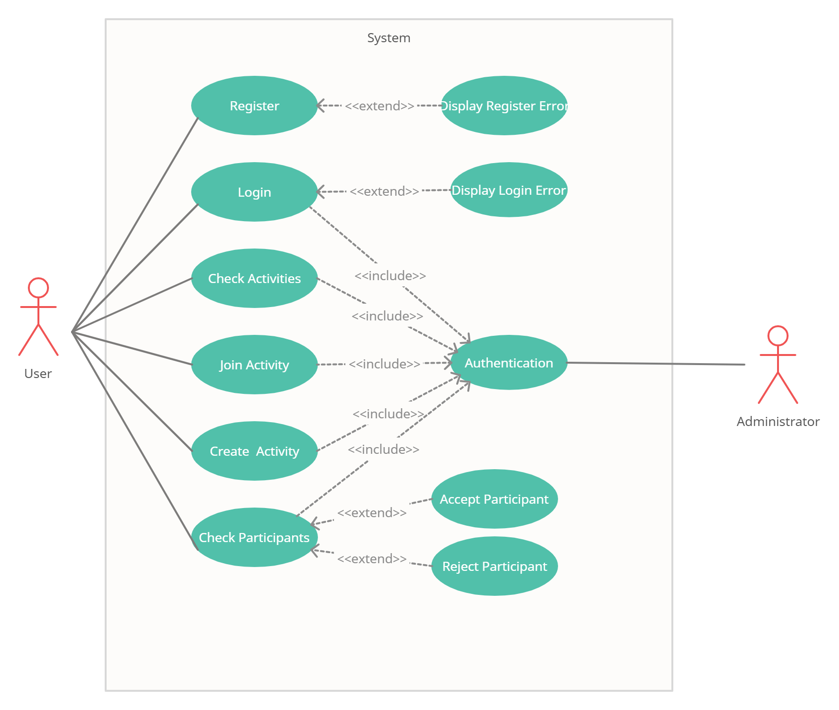

**Architectural Design**

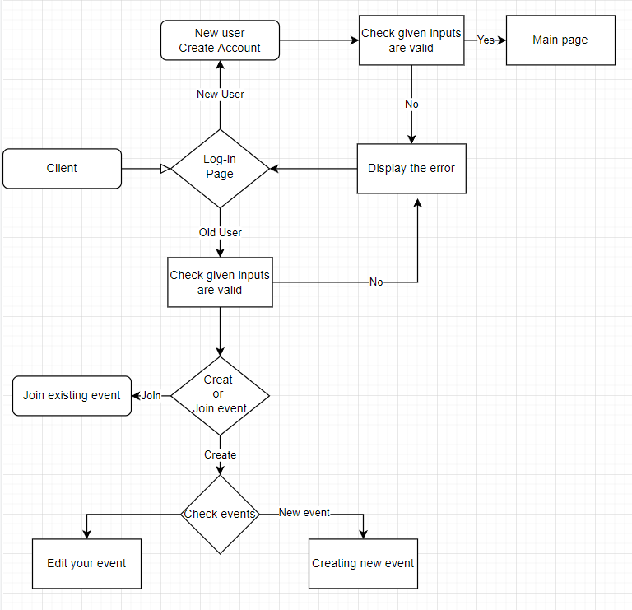

**Database Architecture**

